**Experiment 2**

**Student Name: Yash Gupta UID: 20BCS5009**

**Branch: BE-CSE Section/Group: 20BCS-MM-806 A**

**Semester: 5 Date of Performance: 19-08-2022**

**Subject Name: MMT LAB Subject Code:**

**Aim :-** Procedure to remove the arrows and text from the given photographic image using Adobe photoshop.

**Hardware Requirements: -** Minimum 384MB RAM, 100 GB hard Disk, processor with 2.1 MHz

**Software Requirements: -** Adobe Photoshop, Photopea

**Tools to be used:** Type Tool, Rectangle select(M), Lasso select.

**Study:**

**2.1Procedure to remove text from given image.**

**Step 1 :-** Create the new project and set the dimensions according to the requirement.

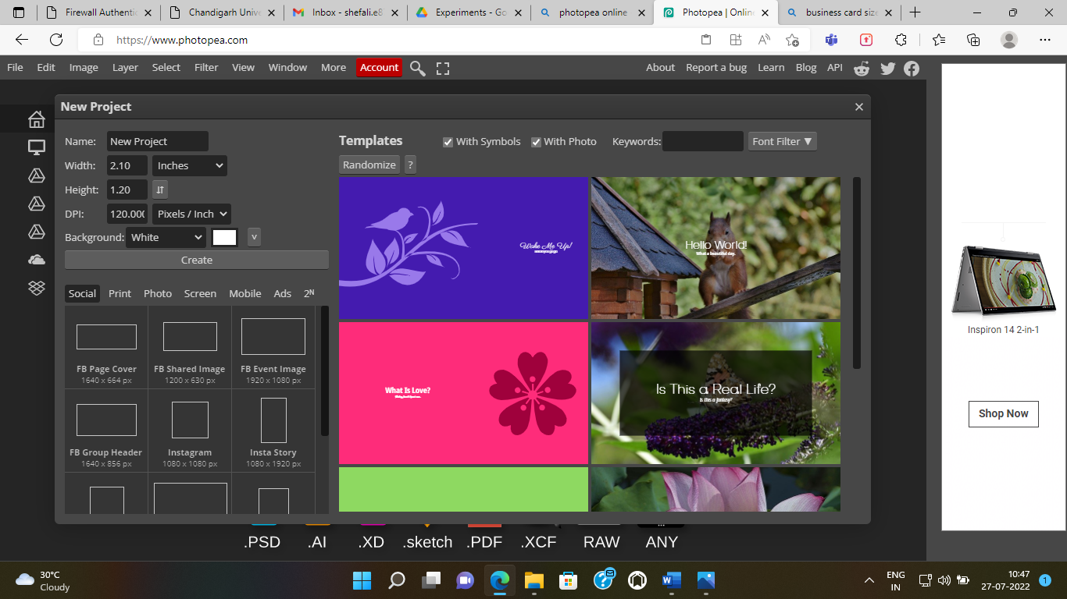

**Step 2: -** Now you have to select the layer1 image for the removing text from the given photographic image . You can take images through various methods.

1. If the image is in your system, then you can take it from FILE ---> Open and place.

2. You can copy the image and paste it on the template.

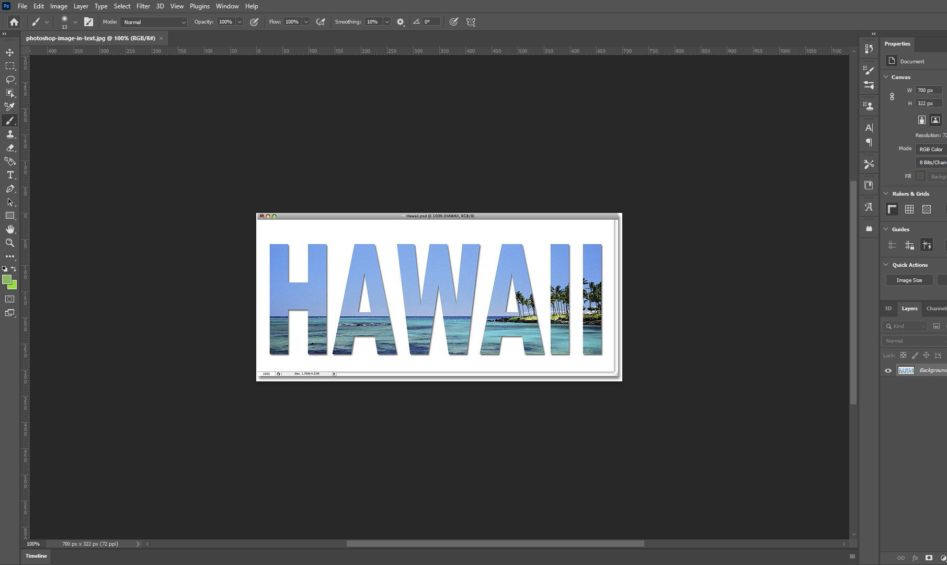

**Step3:-** Brush tool.

**Step4:**- Select the Size & Hardness of brush tool.

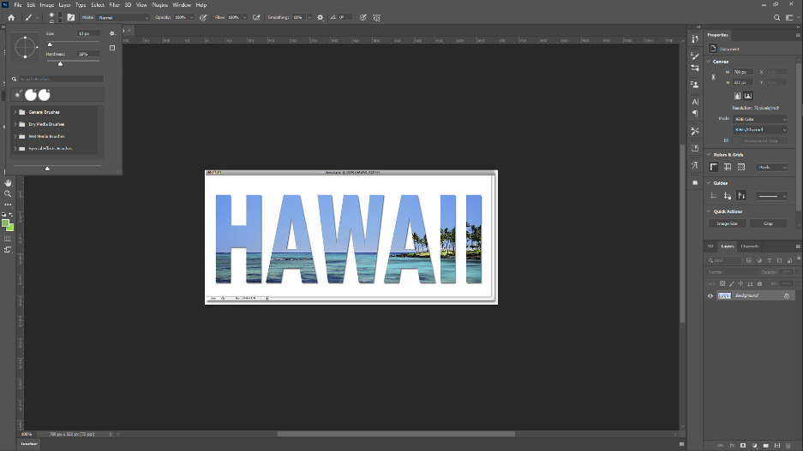

**Step5:**- Start removing the text.

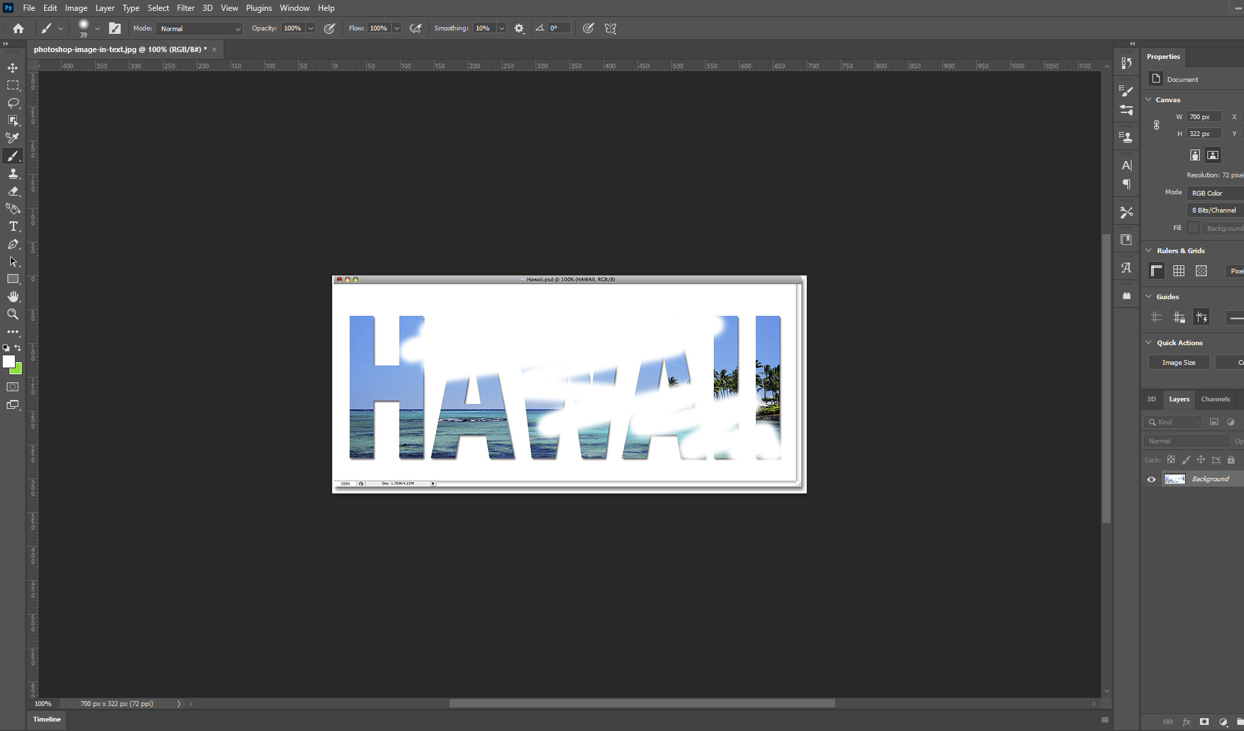

**Output:-**

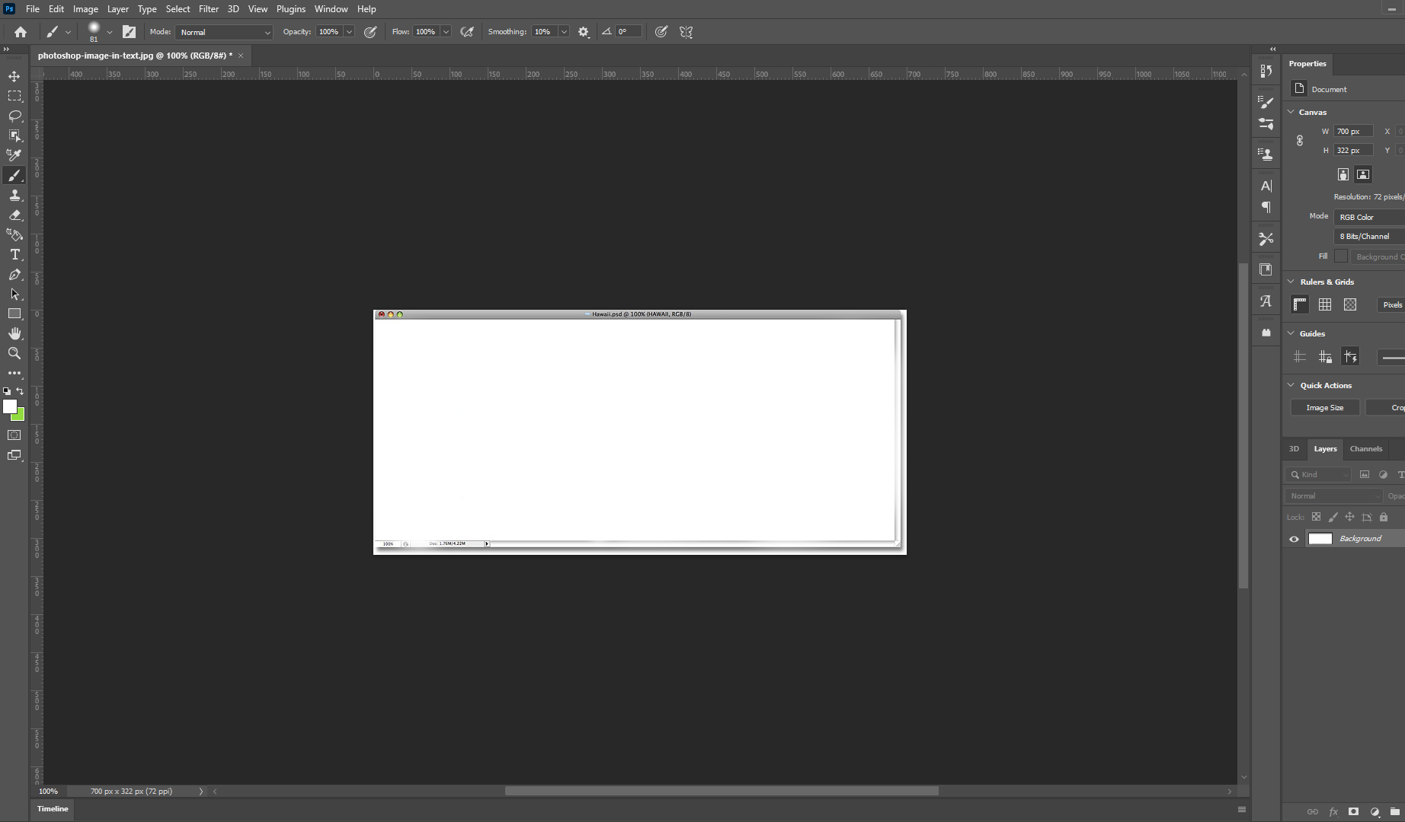

**2.2 Procedure to remove object from given image.**

**Step 1 :-** Create the new project and set the dimensions according to the requirement.

**Step 2: -** Now you have to select the layer1 image for the removing object from the given photographic image . You can take images through various methods.

1. If the image is in your system, then you can take it from FILE ---> Open and place.

2. You can copy the image and paste it on the template.

**Step 3: -** After that we have to select rectangular box then Lasso Select**.**

**Step4:-** Then select the object part of the image.

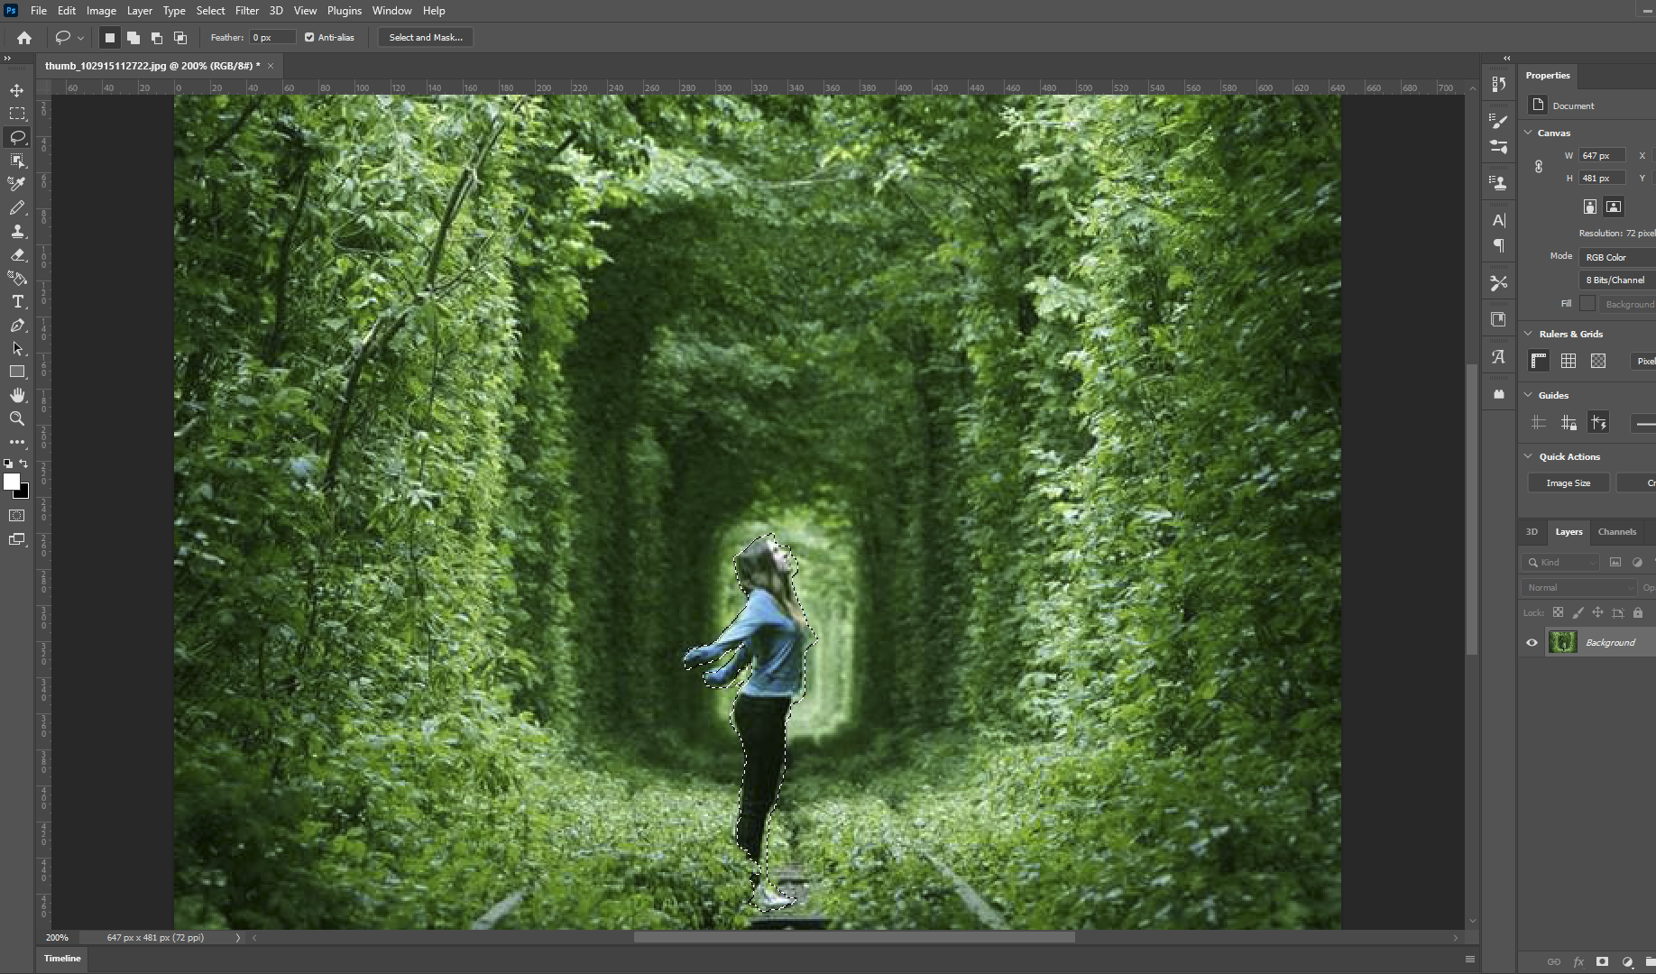

**Step5:-** Select Edit, and then fill.

**Step6:-** Fill, and then content Aware

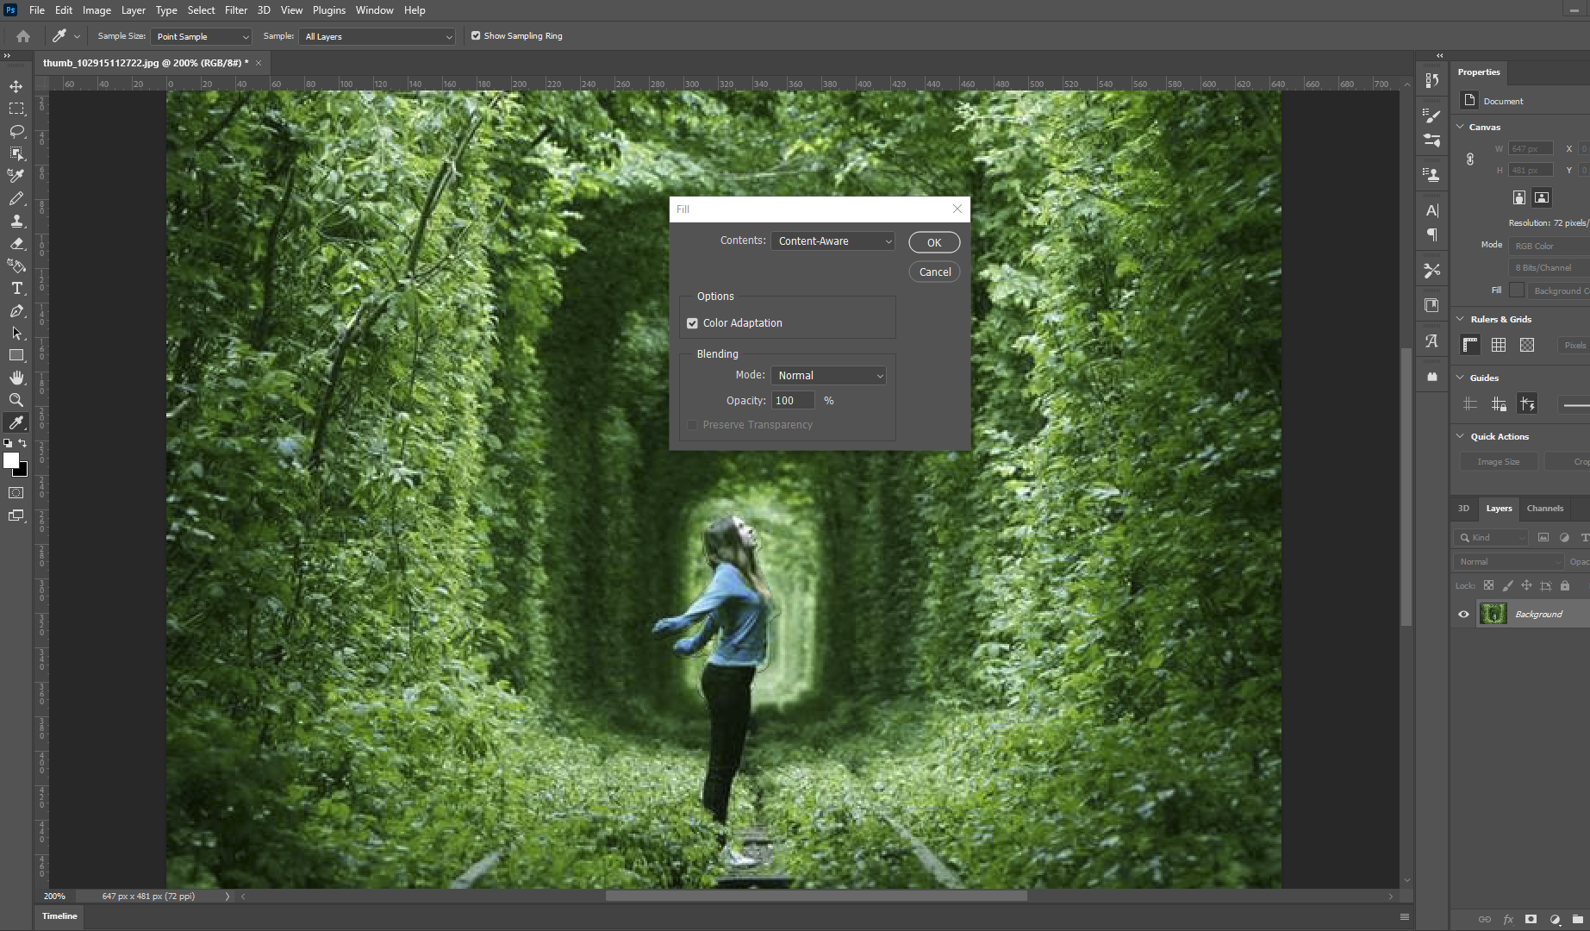

**OUTPUT**

**Step7:-** Object is removed from given image.

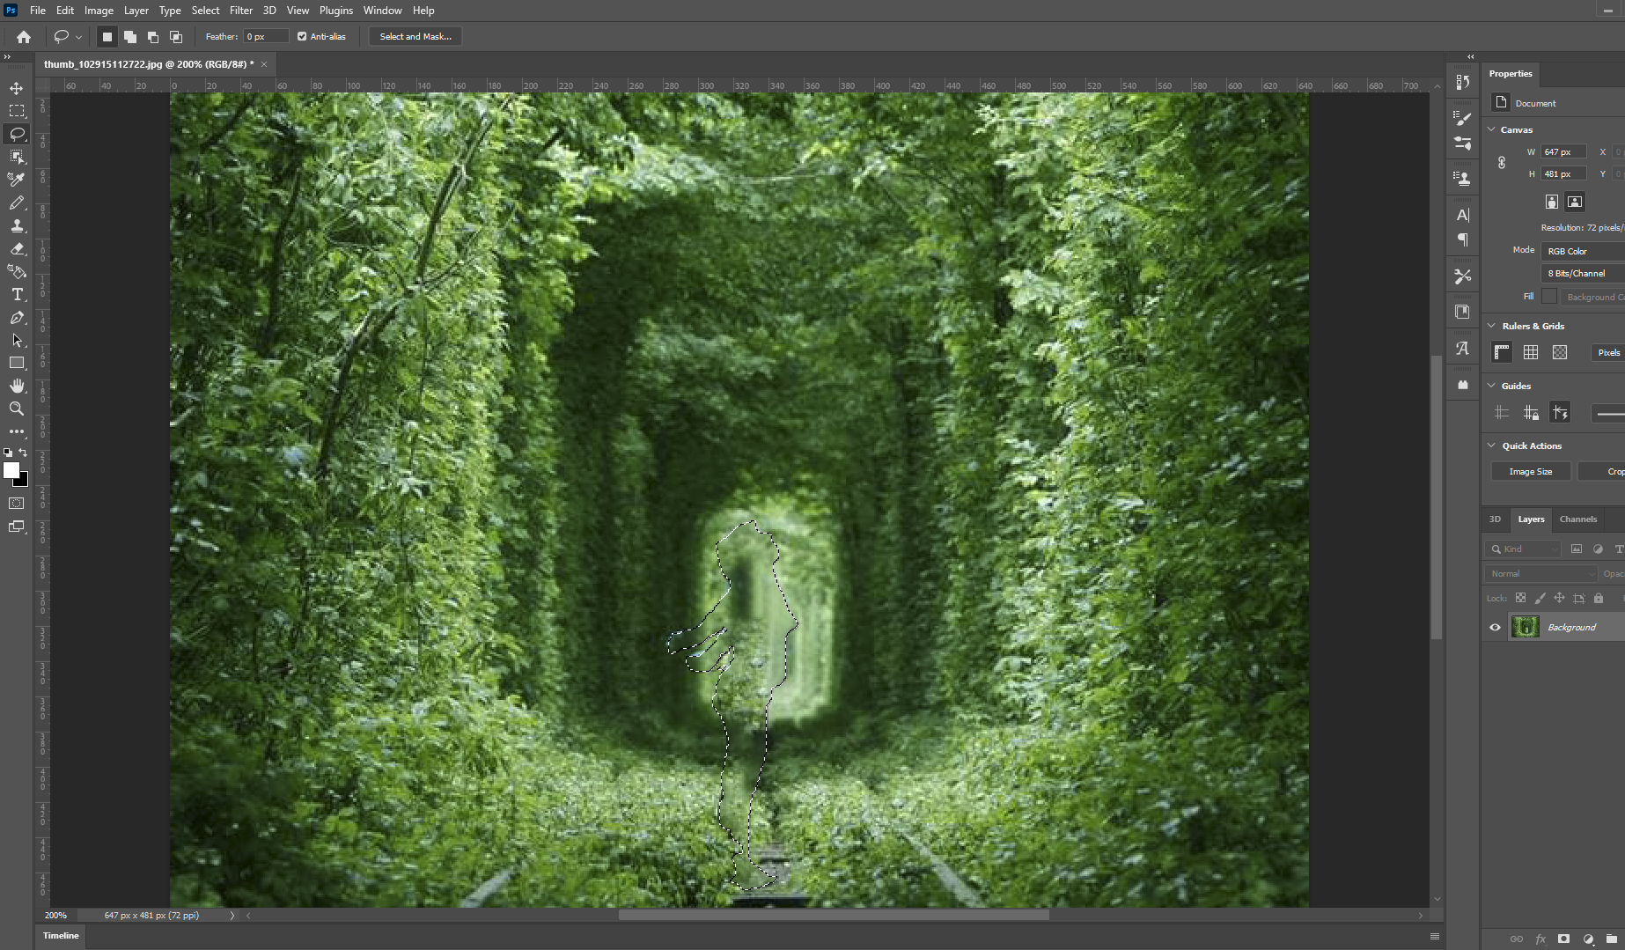

**Evaluation Grid (To be created as per the SOP and Assessment guidelines by the faculty):**

|  |  |  |  |
| --- | --- | --- | --- |
| Sr. No. | Parameters | Marks Obtained | Maximum Marks |
| 1. |  |  |  |
| 2. |  |  |  |
| 3. |  |  |  |
|  |  |  |  |